2 – Input OR Gate Using Transistor
Project Description

Project Name | 2 – Input OR Gate Using Transistor
Course Title | Basic Electronics - LAB
Submission Date | 15-July-2025
Faculty | Faculty Of Information Technology
Software Used | Tinkercad

- Executive Summary :
This project demonstrates the implementation of a 2-input OR logic gate using NPN transistors. The primary objective was to design and test a basic OR gate using discrete electronic components rather than integrated circuits (ICs). This hands-on lab activity aimed to help students understand the behavior of logic gates at the component level, reinforcing concepts of digital electronics, transistor switching, and circuit logic behavior.
- The project successfully replicated the OR gate functionality: the output was HIGH (LED ON) when either or both inputs were HIGH, and LOW (LED OFF) when both inputs were LOW.
- Methodology - Circuit Diagram :

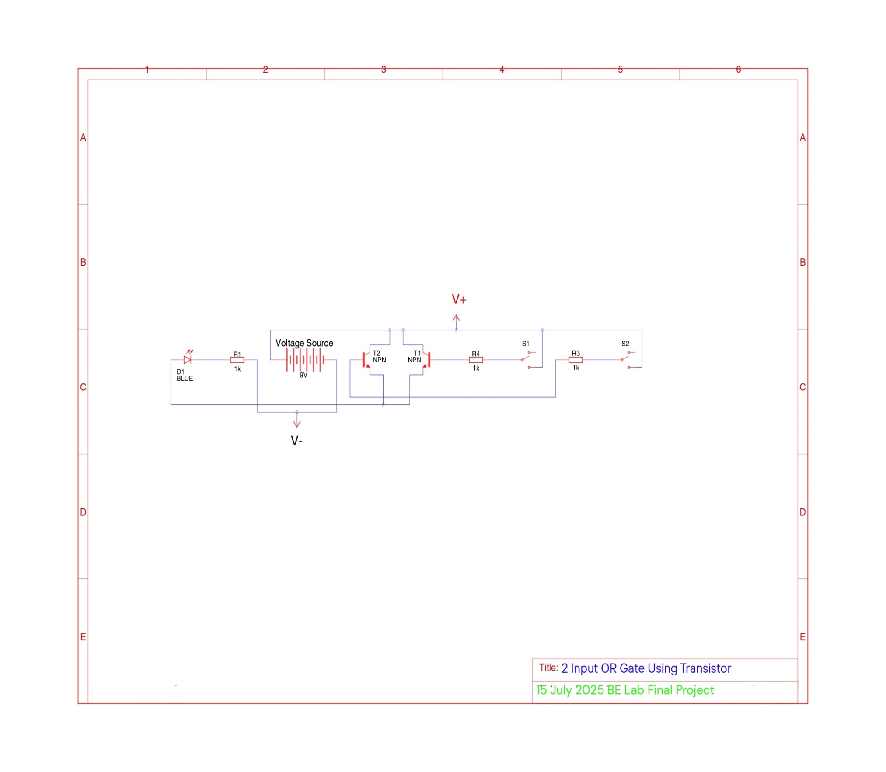

Circuit Diagram On Tinkercad :

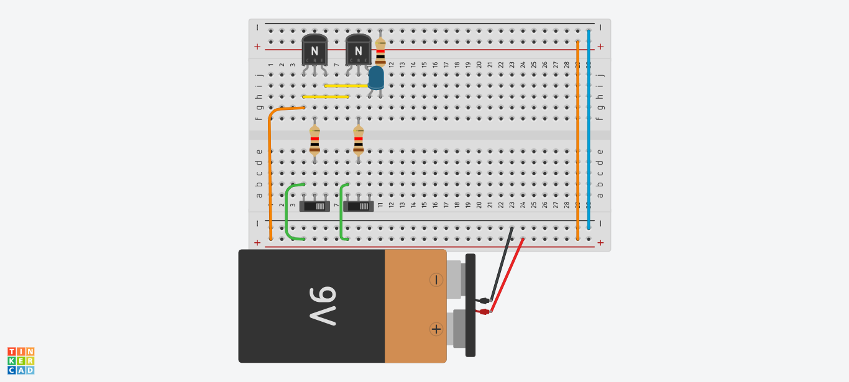

Components Used :
- Breadboard
- 2 NPN Transistors (T1 & T2)
- 2 Switches (S1 & S2) as inputs
- Resistors (R1 to R3) to limit base and LED current
- 1 Blue LED (D1) for output visualization
- 9V DC power source

- Implementation Steps :
- Connected V+ (9V) and V- (GND) as the main power supply.
- Placed two NPN transistors (T1 and T2) in parallel at the output stage.
- Connected the base of each transistor to individual resistors (R3 & R4), followed by input switches S1 and S2.
- Connected a blue LED in series with a resistor (R1) to the collector side of the transistors.
- Grounded the emitters of both transistors.
- Tested the output by sliding each input switch and observing LED behavior.
- Results and Findings :

- If no switch is slide to on → LED OFF
- If S1 is slide to on → LED ON
- If S2 is slide to on → LED ON
- If both are slided to on → LED ON
This confirms the OR gate behavior using basic components.

Switch S1 (A) | Switch S2 (B) | LED Output (OR)
0 (OFF) | 0 (OFF) | 0 (OFF)
1 (ON) | 0 (OFF) | 1 (ON)
0 (OFF) | 1 (ON) | 1 (ON)
1 (ON) | 1 (ON) | 1 (ON)

- Positive Outcomes :
- Built a fully working 2-input OR logic gate using only basic components.
- Verified OR logic truth table using physical switches and observed output through an LED.
- Deepened understanding of transistor switching and circuit-level logic design.

